Hi families!
Our program has partnered with brightwheel, the leading early education app, for parent communication, easy sign in and out app and more. It is highly reviewed, secure, and commended for its ease-of-use. We’re excited for you to see what it’s all about!
Soon, you’ll receive an email or text invitation from brightwheel to connect to your child’s profile. Simply click the link in the brightwheel message to finish creating your account. If you already have a brightwheel account, it will automatically link to our program when you click the invite link.
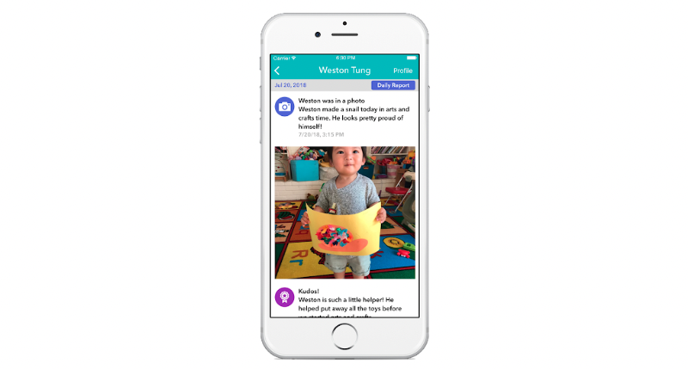
You can sign in to brightwheel on both a web browser and via their mobile app. You can download their mobile app in the Apple and Google Play app stores.
For technical support, brightwheel offers families direct support via help@mybrightwheel.com. There is also a handy FAQ page here.
See you all on brightwheel!
Snow & Dan

